**OSRIKGROUP WEBSITE STATIC CONTENT REQUIRED**

1. 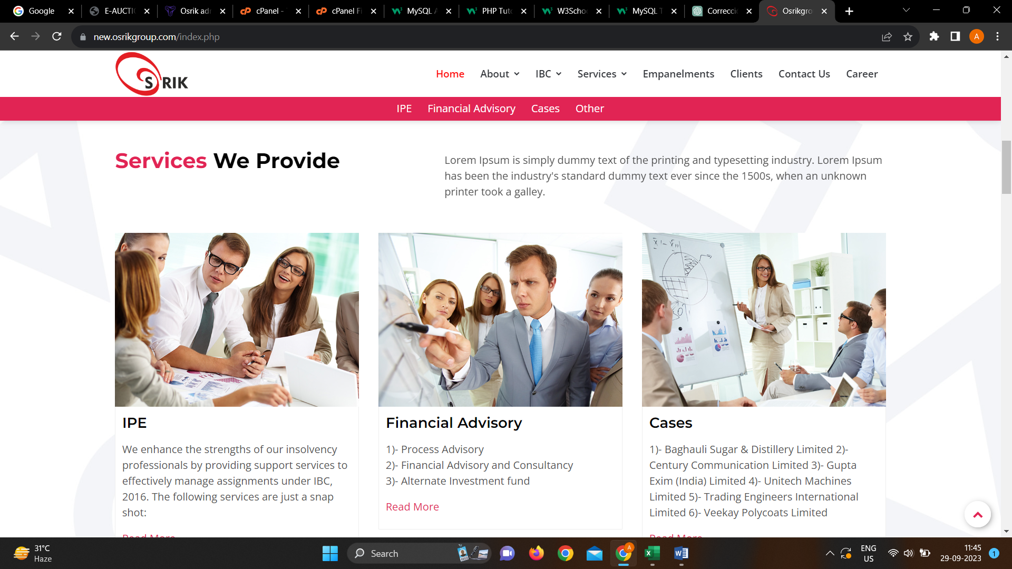**Images of service we provide**
2. 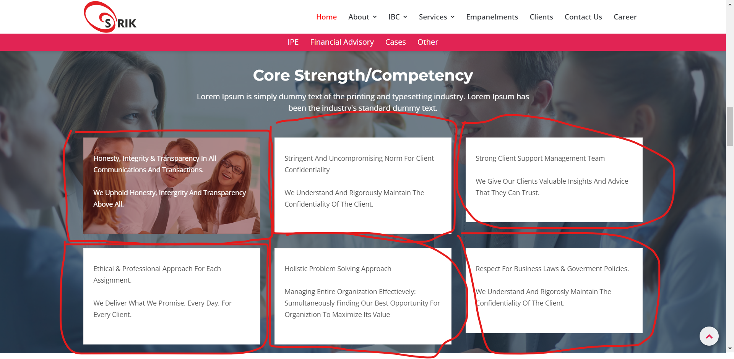**images of background**
3. 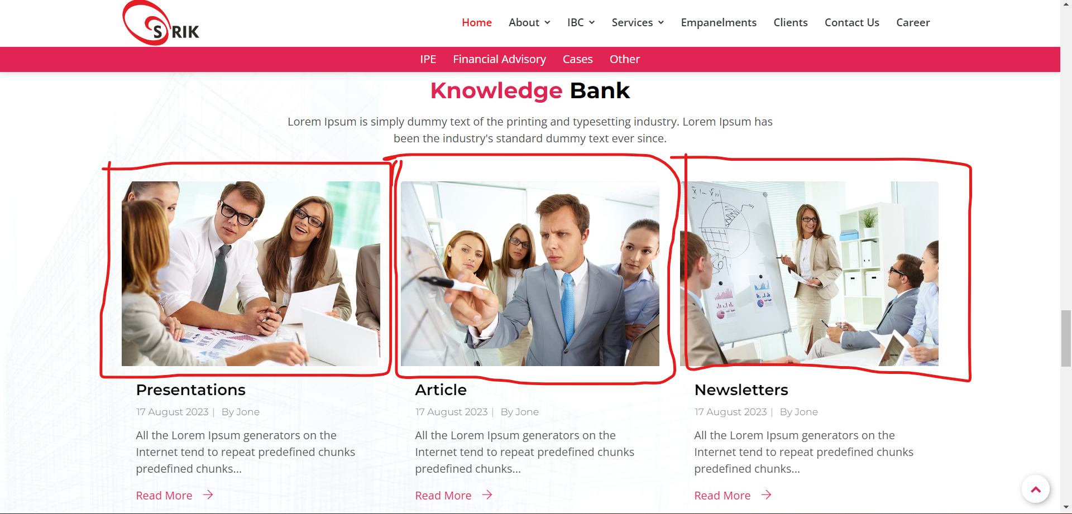

**Images of the these knowledge bank**

1. 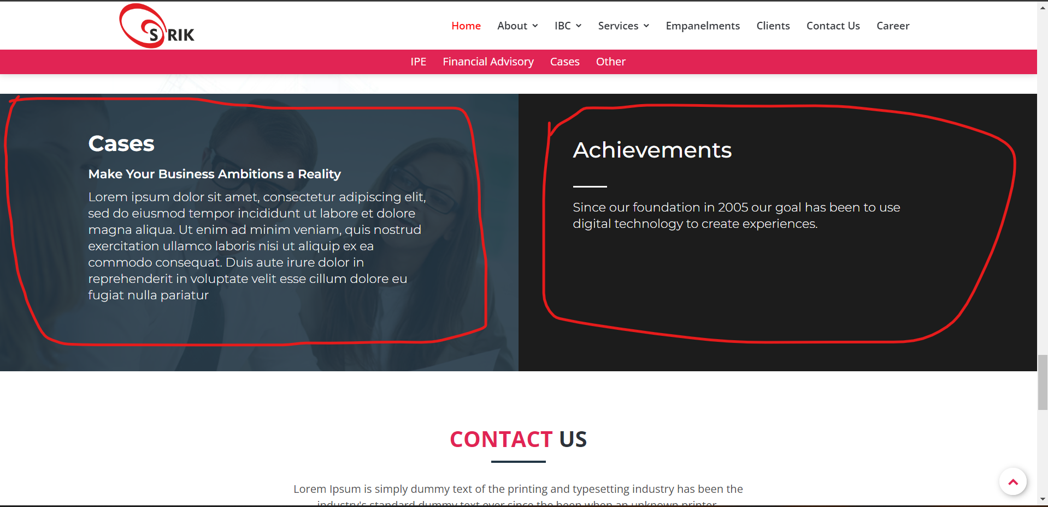

**Cases content and Achievements**

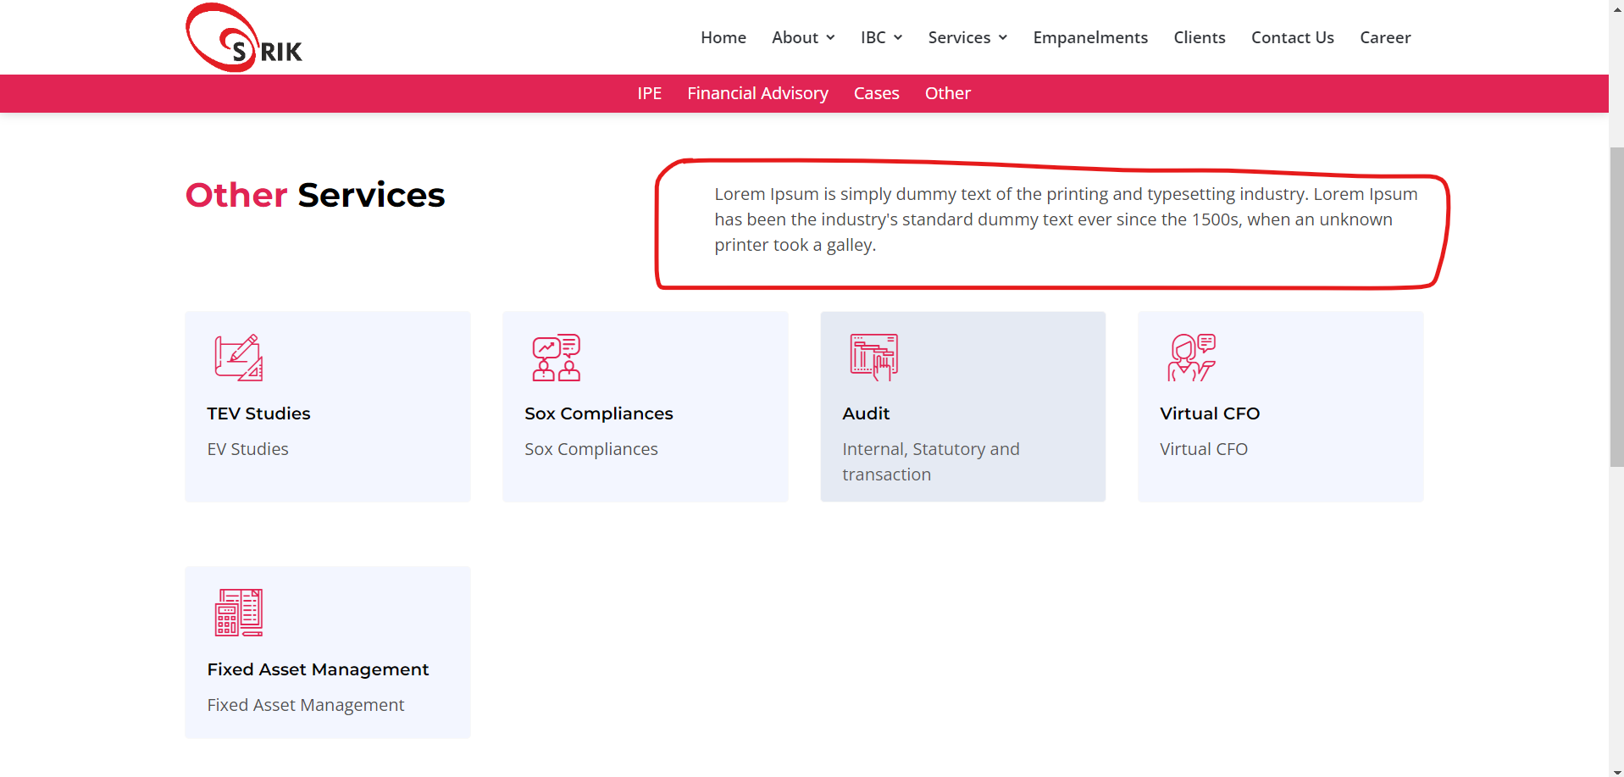

1. **Other services content**
2. 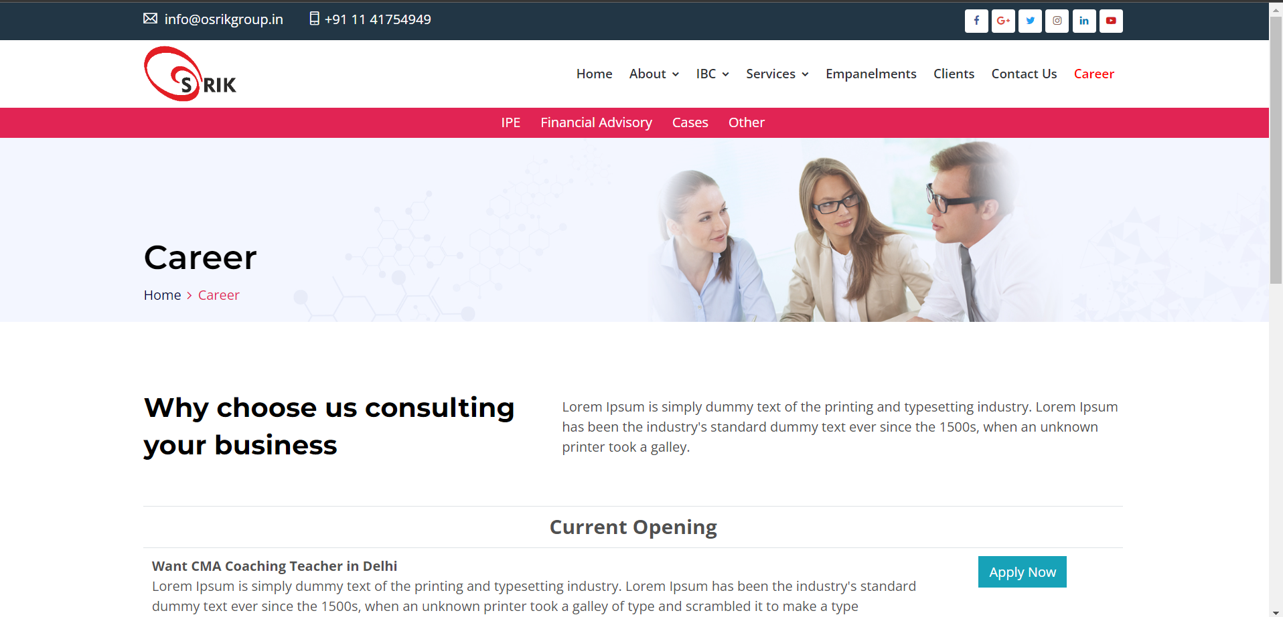

**Career page content**

1. 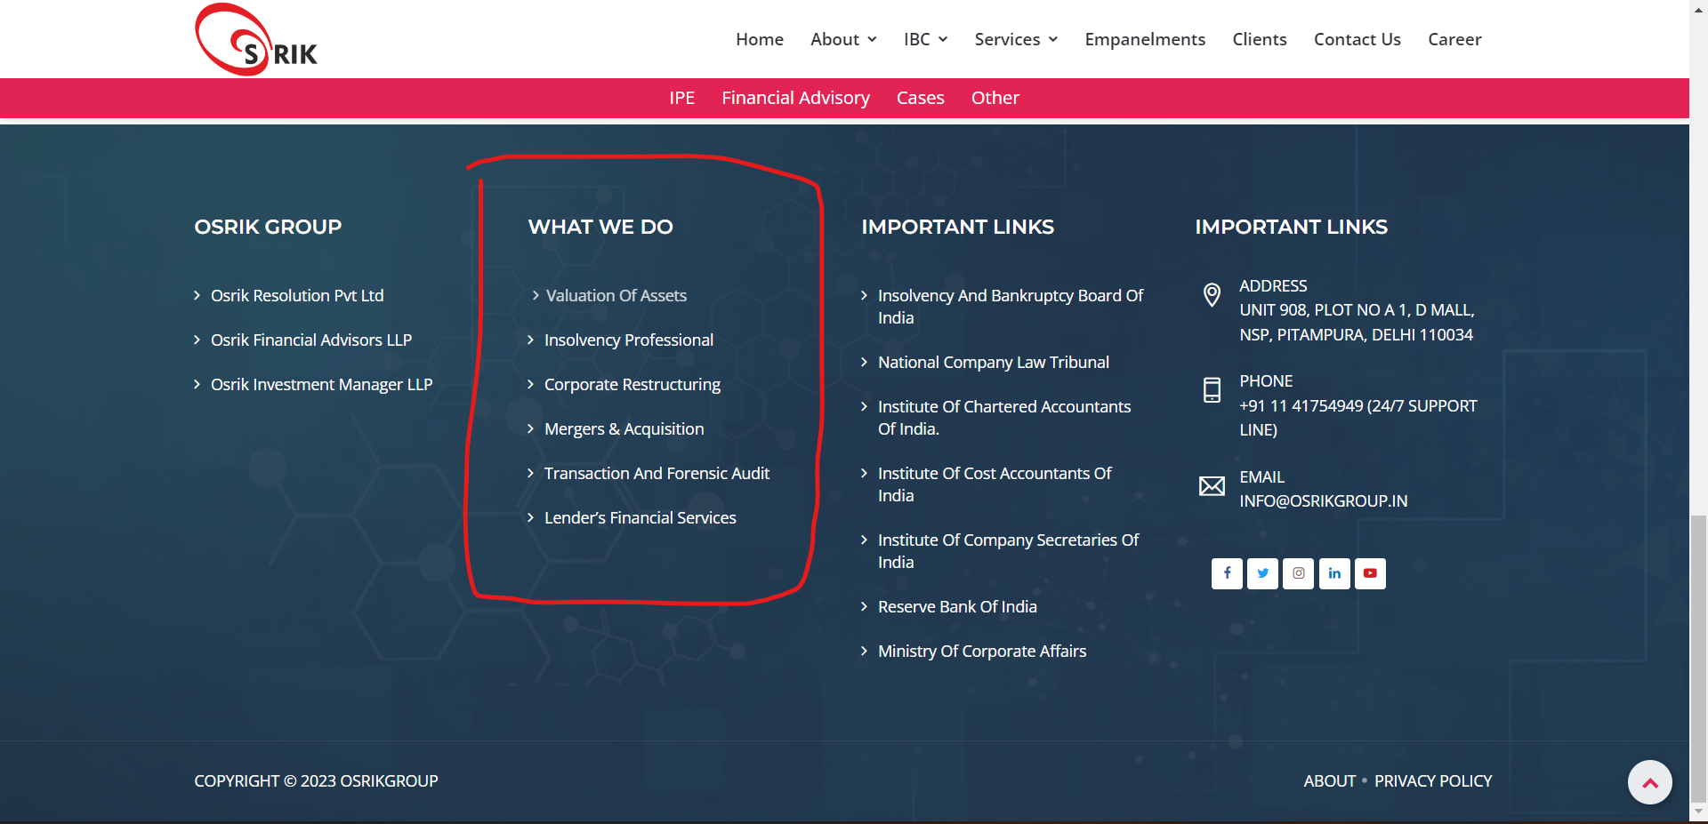

**Provide these links**